LAB SHEET 05

ID NO: IT24101569

Thilakarathne W.A.K.G.N

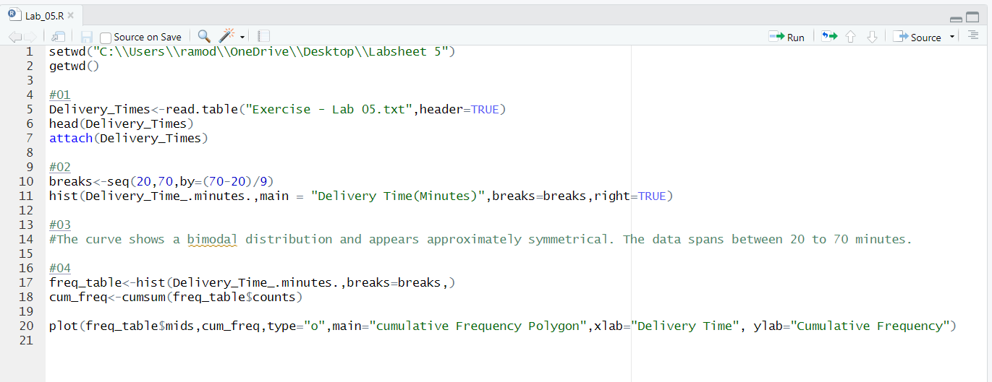

Question 03

* The curve shows a bimodal distribution and appears approximately symmetrical. The data spans between 20 to 70 minutes.



